
Optimization of arsenic extraction in rice samples by Plackett-Burman design and response surface methodology

The objective of this research paper is to optimize the extraction condition of arsenic species and dimethylarsonic acid in paddy rice by a simple solvent extraction using water as an extraction reagent. Design of experiments (DoE) methodology is implemented for the estimation of the variable effects.
The factors (independent variables) examined are: T = extraction temperature (ºC), t = shaking time (min), R = rotation speed (rpm), V = solvent volume (mL) and D = dummy factor. All the factors are continuous. The responses (dependent variables) examined are: Y₁ = As (III) extraction (mg/kg), Y₂ = As (V) (mg/kg), Y₃ = DMA extraction (mg/kg) and Y₄ = sum of arsenic species (mg/kg). The applied DoE method is Plackett Burman design.
Isalos version used: 2.0.6
Scientific article: https://www.sciencedirect.com/science/article/abs/pii/S0308814616302977

Step 1: Plackett Burman Design
In the first tab named “Action” define the factors in the column headers and fill each column with the low and high levels of the corresponding factors. This tab can be renamed “Plackett Burman”. Afterwards, apply the Plackett Burman method: DOE $→$ Screening $→$ Plackett Burman

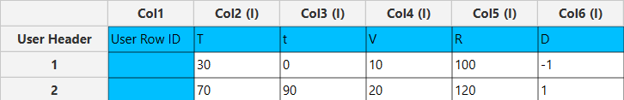

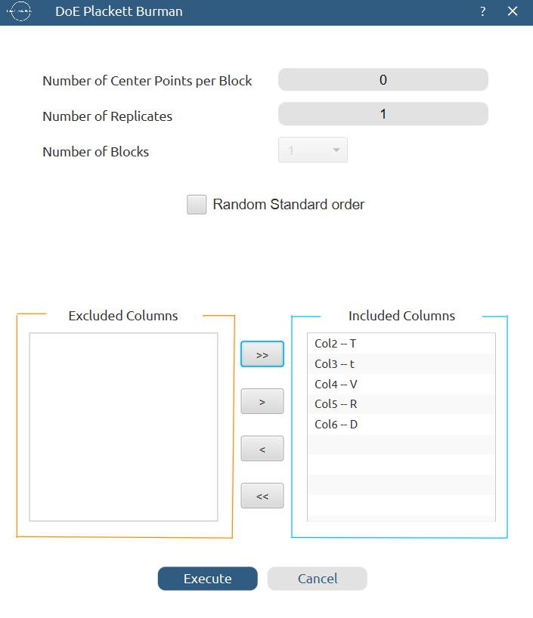
(old)

Results (right spreadsheet):
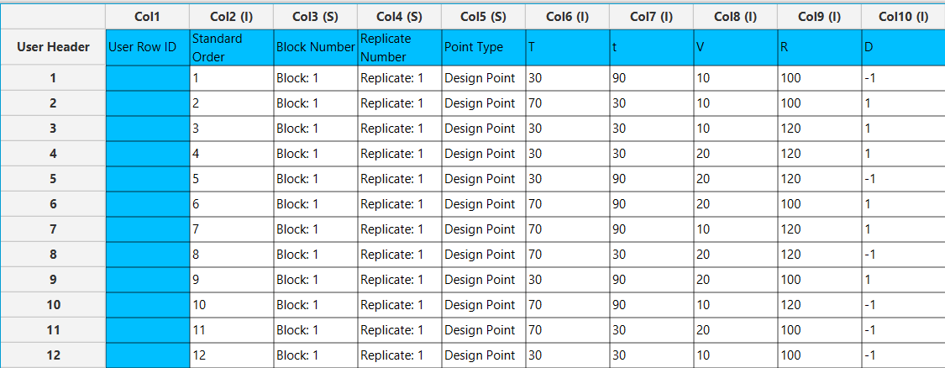

Step 2: Definition of response variables
Create a new tab named “Responses” and define the responses in the column headers. Fill each column with the values of the corresponding responses that were observed and make sure the values follow the order of the experiments as given by the Plackett Burman method. Then, select all columns to be transferred to the right spreadsheet: Data Transformation $→$ Data Manipulation $→$ Select Column(s)

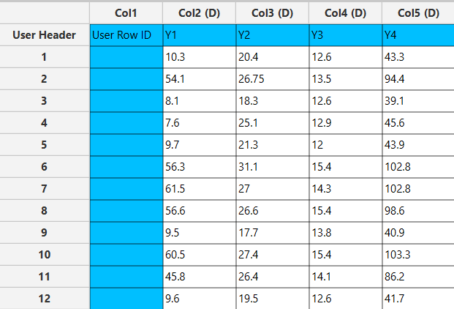

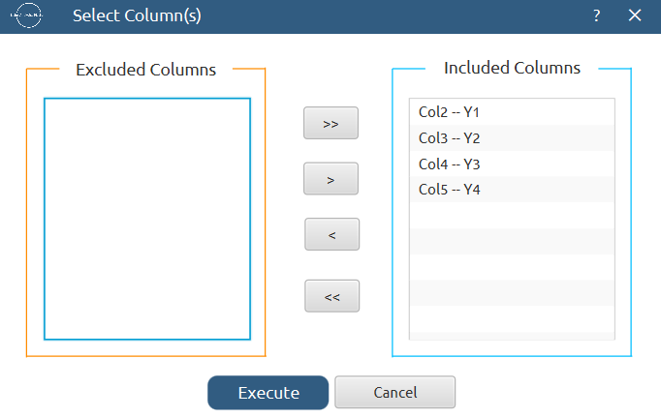

Step 3: Data isolation
Create a new tab named “Data” and import the results from the “Plackett Burman” and “Responses” spreadsheets by right clicking on the left spreadsheet. Then, select only the factors and responses columns to be transferred to the right spreadsheet: Data Transformation $→$ Data Manipulation $→$ Select Column(s)
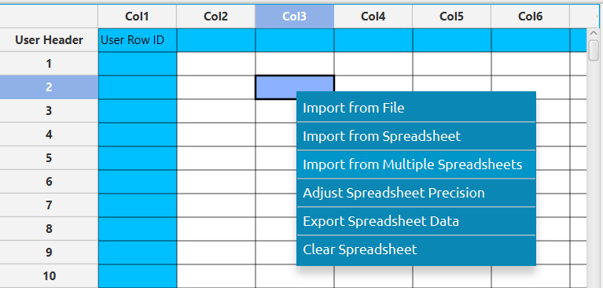

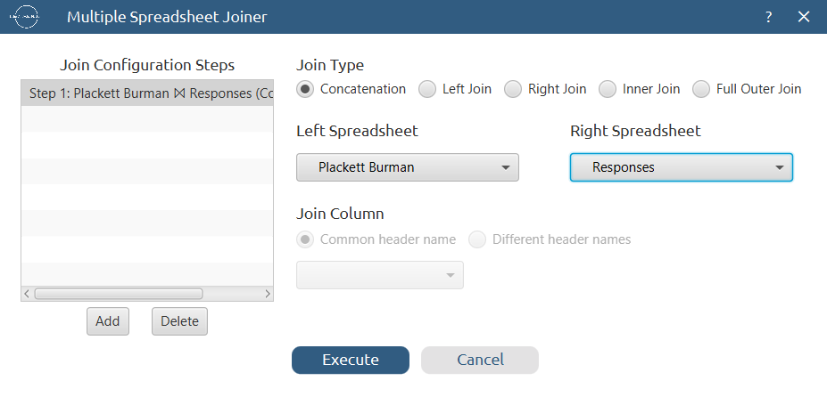

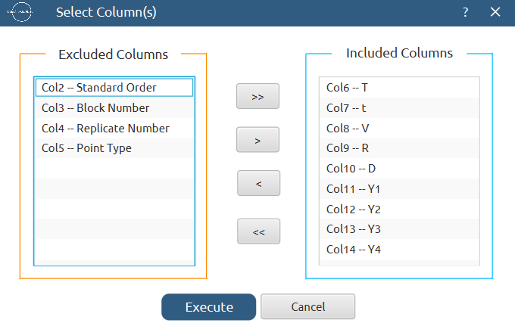
Results:
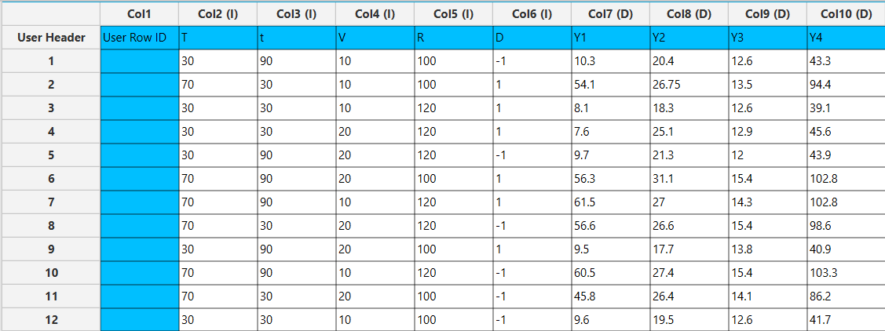

Step 4: Pareto analysis
Create a new tab named “Pareto Analysis – Y1” and import the results from the spreadsheet “Data”. Then, conduct pareto analysis for the first response variable, Y₁: DOE $→$ Post DoE Analysis $→$ Pareto Analysis

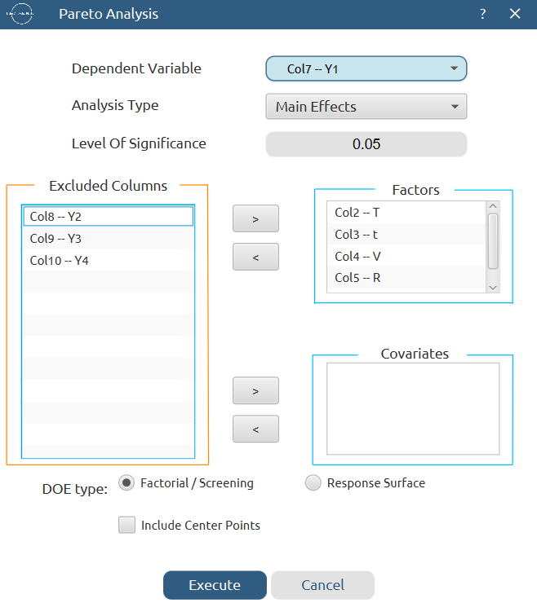
Results:
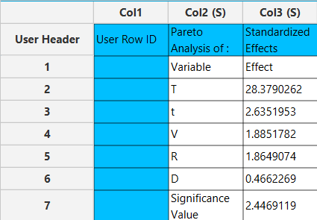

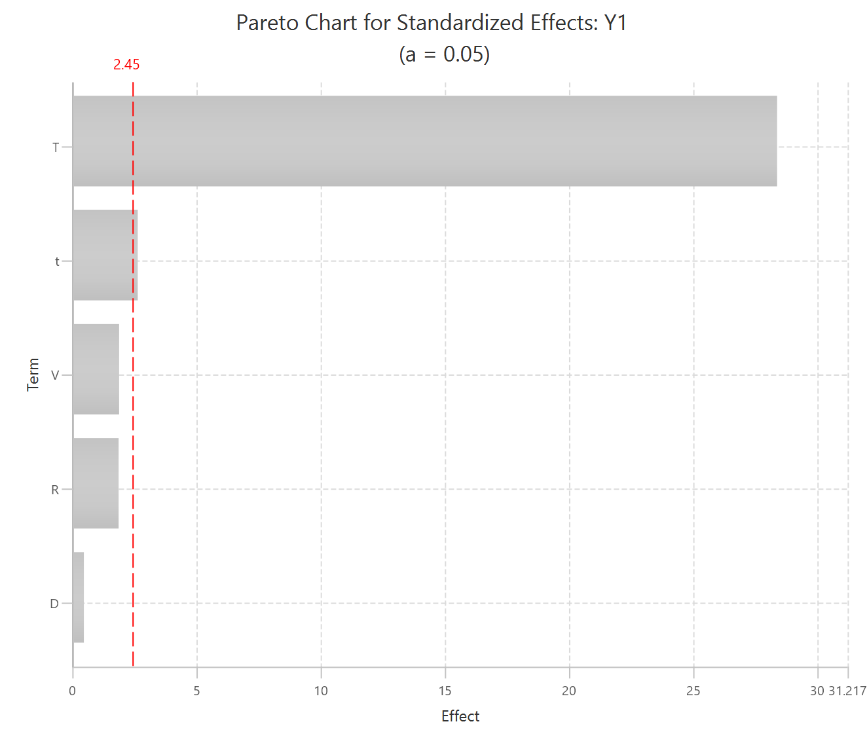

Repeat this step for the rest of the response variables. Results, Y₂:
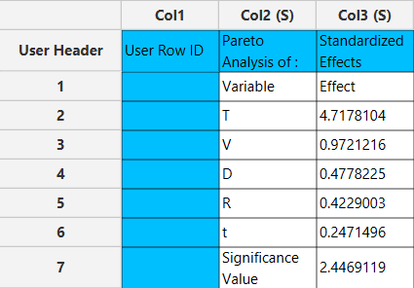

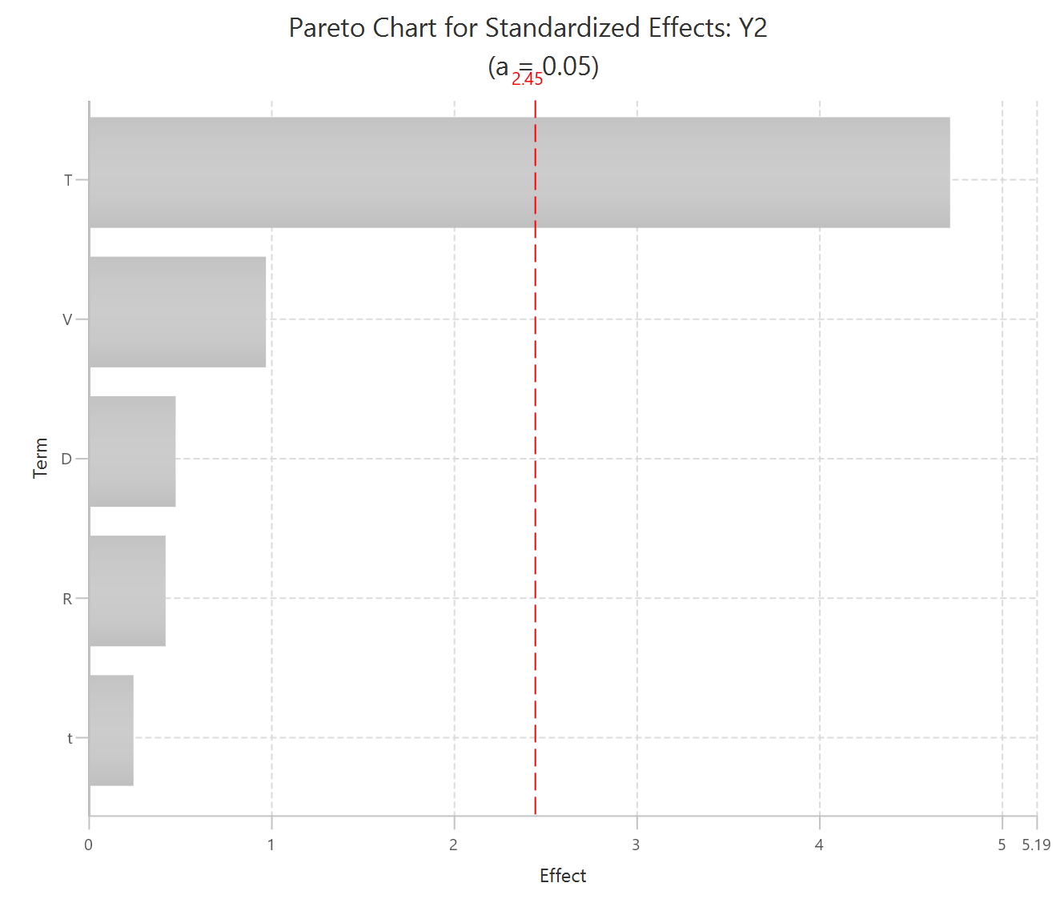

Results, Y₃:
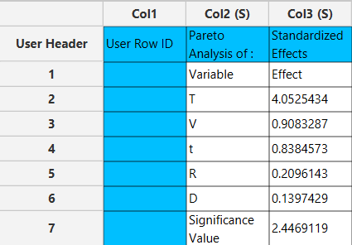

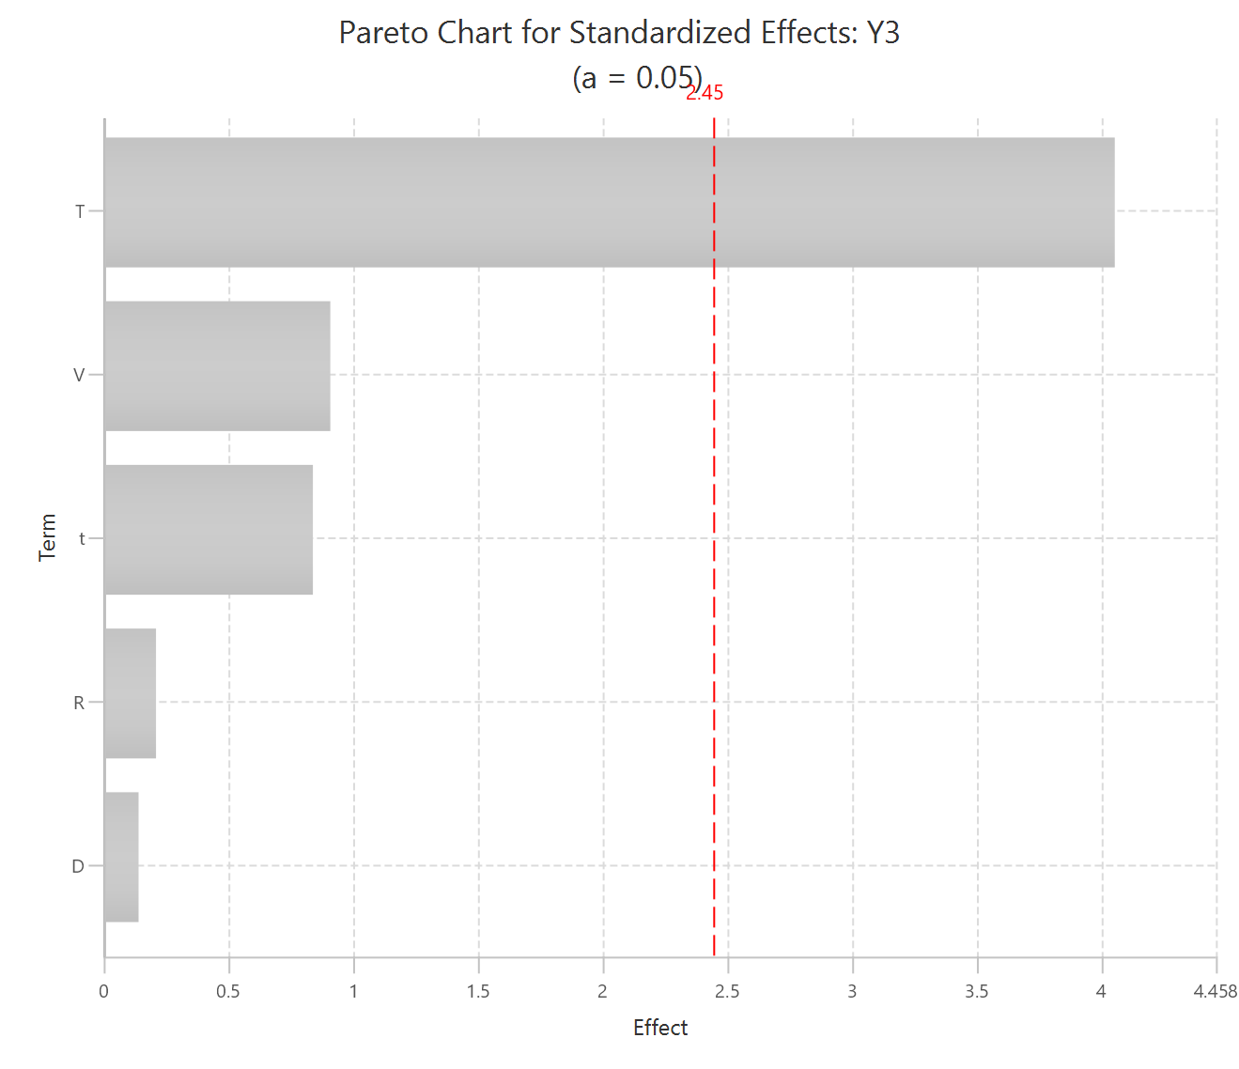

Results, Y₄:
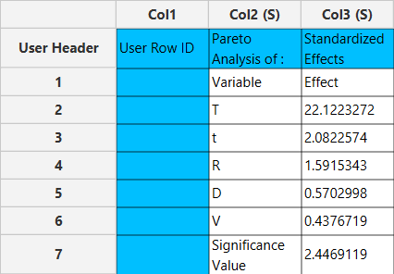

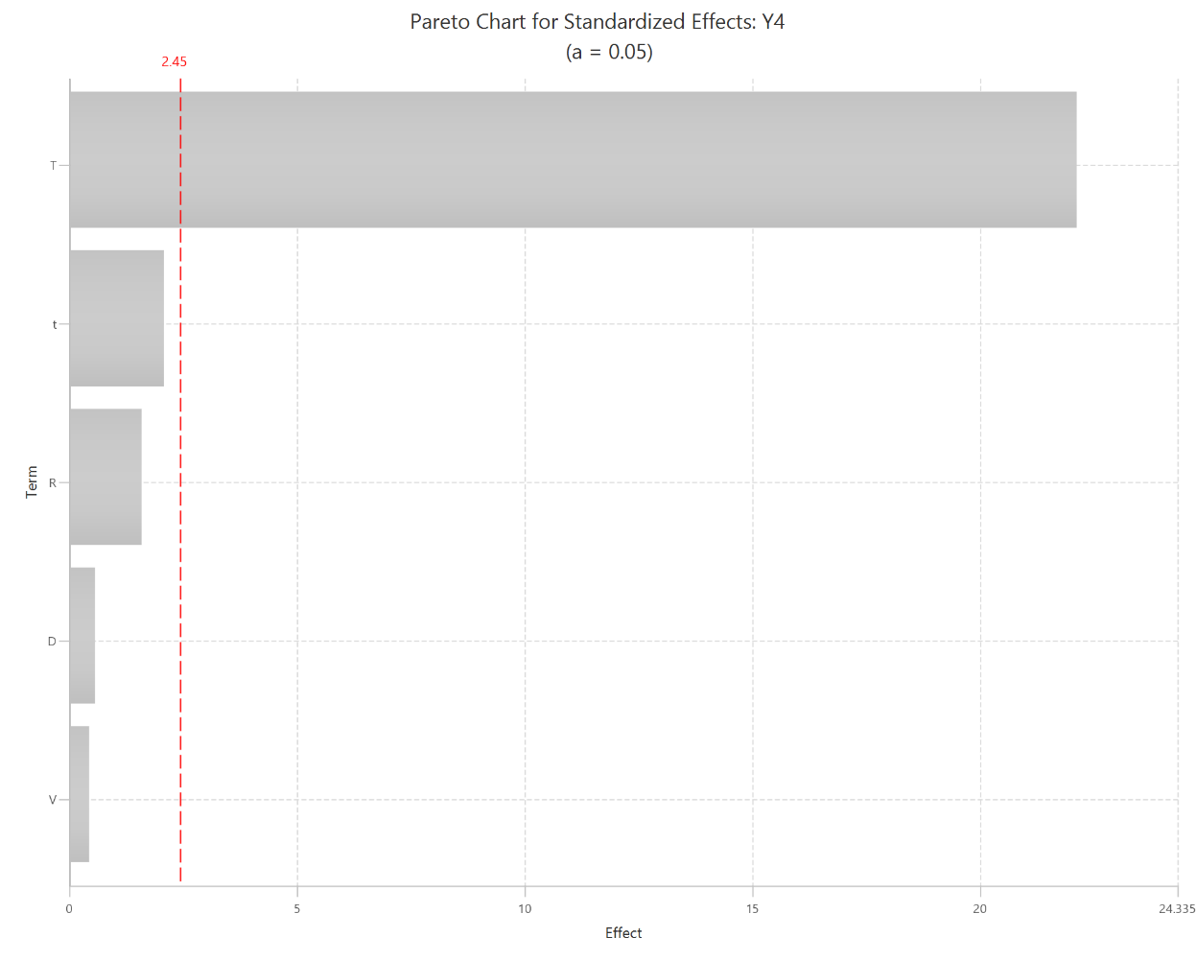

Final Isalos Workflow
The final workflow is presented below:
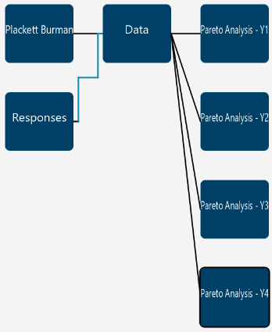

References
- Ma, L.; Wang, L.; Tang, J.; Yang, Z. Optimization of Arsenic Extraction in Rice Samples by Plackett–Burman Design and Response Surface Methodology. Food Chemistry 2016, 204, 283–288. https://doi.org/10.1016/j.foodchem.2016.02.126.

